The program can be accessed by going to: water.mse.ucdavis.edu
Below is a screenshot of the website when it first opens,
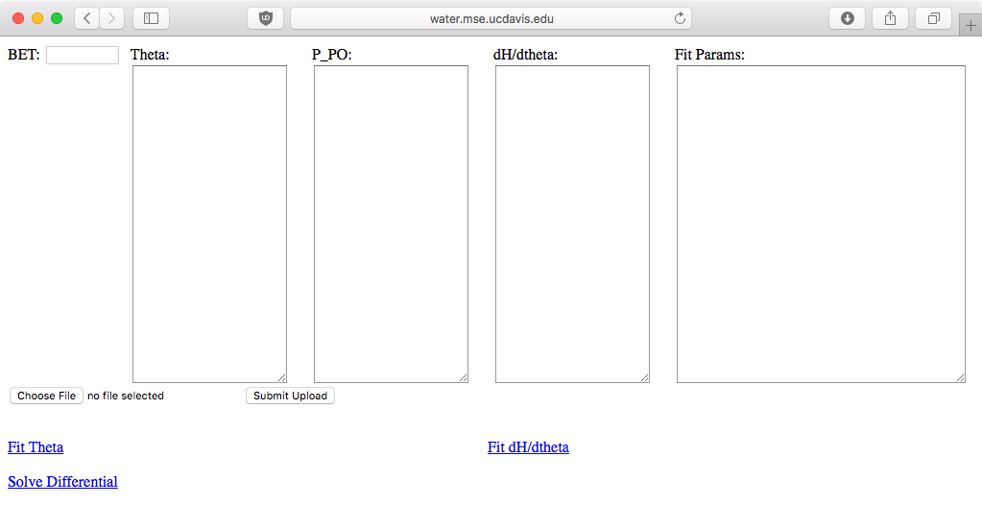
1
2
3
The data can be inputted manually, by cutting and pasting the data into the boxes. If you choose to do so, then the format is to put one datapoint per line. The other option is to upload a CSV file, with 3 columns by clicking “Choose File” (2). These columns must be called: “exp_theta, exp_p_po, exp_dH”. A CSV can be saved using Excell or Google Sheets, just ensure that you choose “Comma-Separated Values (UTF-8)” under save-as. Once you have chosen the file, the textboxes will populate themselves with the data when “Submit Upload” (3) is clicked. BET must always be inputted manually (1). The data should look like this:
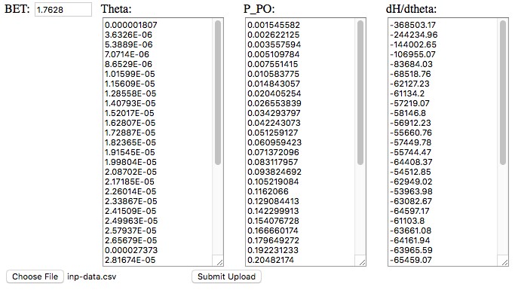

The next step is to generate the fit paramters by fitting theta and dH/dtheta. To do this, click the blue “Fit Theta” and “Fit dH/dtheta” buttons.

This will generate two plots and populate the Fit Parameters box, as shown below:

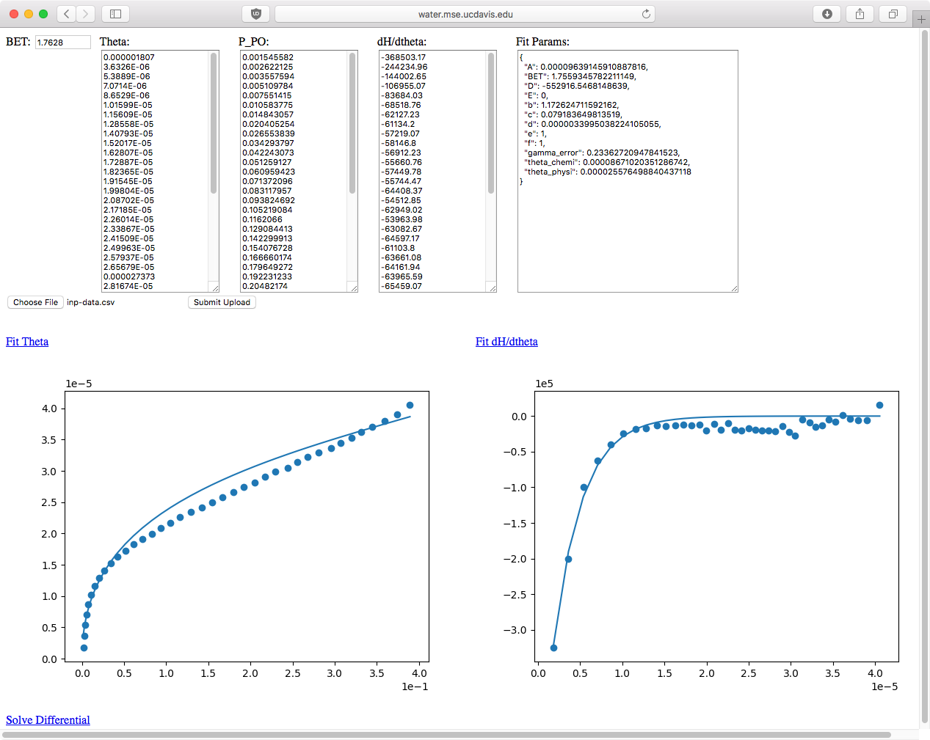

Once this is complete, click the “Solve Differential” button, to solve the differential equation for gamma. This solution takes about 18-19 minutes to run on the server. Once the solution is complete, the page will look similar to below:
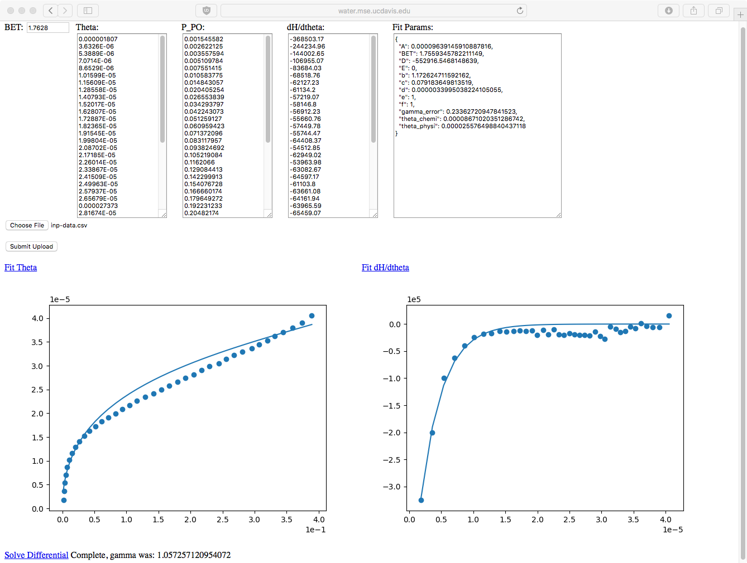

As you can see, next the Solve Differential button, the resulting gamma is displayed. Once the gamma is shown, the site automatically downloads a CSV of the processed data. You can choose where to download the CSV by specifying a default download location in the browser settings. This CSV has 10000 rows, and 4 columns: p_po, theta, gamma, uads.

